Milestone 6 Presentation build
I will first construct the <theory-of-the-program>, then generate <program text> only after the theory is explicit.

OPERATIONAL_DIAGNOSTIC
Substantives_Demolished Replace vague uses of confidence, understanding and reliability with the actions and records below.
Occult_States_Removed Replace we know the project with each partner launching the selected build, tracing an input and demonstrating its consequence.
The_Language_Game Present only behavior present in the selected build; rehearse that same route and record any failed step.

CONTROL_SURFACE_DRAFT
Rehearse the exact presentation build, prepare one slide or a one-page summary, and demonstrate the start, interaction and ending to another group.
Start with Open the verified beta, final title, designer statement, four screenshots, revision results, credits and known limitations. Identify the setup intended for the demonstration.
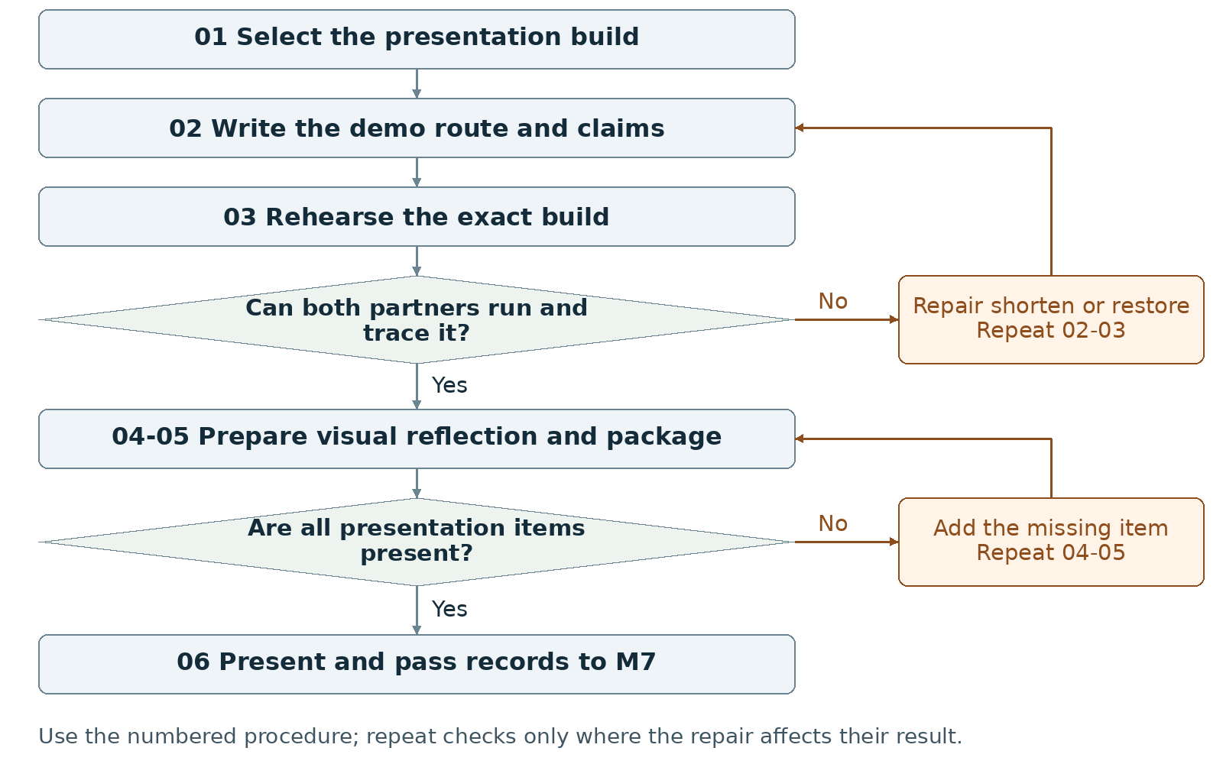
Required package Submit the presentation build, one slide OR a one-page visual summary, self-assessment and required records.
Assign maker __________ and checker __________. Swap roles at the next task. Leave checks pending until performed.

Milestone 6 Write the rules

1 <Initial Interpretation>
Write the demonstration sequence: <presenter> [launches] <build>, [shows] <title>, [uses] <control>, [shows] <consequence>, and [reaches] <ending>. Point to the film-derived theme, interface or rule that the audience can inspect in that sequence.

2 <Theory Skeleton>
Record | What to write
<Entities> | Track the selected build, launch instructions, presenter, demo input sequence, visual summary, backup and observed feedback.
[Operations] | Launch, introduce the goal, operate a control, show the result, identify the WarGames link and answer by pointing to a rule or code location.
<States> | Include title, main interaction and ending in the demo. Record which optional states the short route omits.
<Conditions> | Name the input guards and ending conditions used on the demo route. Keep rehearsal and backup checks in steps 01-03.
<Invariants> | For each scoped runtime invariant used on the demo route, name the stored values involved and check them during rehearsal.
<Constraints> | Check title, controls, readable instructions, beginning/middle/end and credits. Provide one slide or one-page visual summary and a self-assessment paragraph.
Use conditions to decide whether an action or transition is allowed. State the scope of each invariant and how to check it. Keep submission requirements separate from runtime rules.

3 <Assumption Ledger>
Status | Action
<safe> | Enter an unverified premise only with its basis and limited consequence if wrong. Keep checked beta results and limits in the rehearsal inputs.
<uncertain> | Record untested display size, browser, network or input hardware in the presentation setup.
<requires-user-decision> | Have the group choose the final demo route, speaker handoffs and any late repair. Do not promise unimplemented work.
Write {setup, claim, verification action, person, result}. Name the exact build in the rehearsal record and on the backup folder.
Record the next open item Claim __________ Status __________
Owner __________ Evidence/check __________ Next action __________
Write <entity> for a person, object, value or state; [operation] for an action; and {record} for related fields. Record planned, observed, failed or not tested beside each claim. Do not mark a check passed until a person performs it and records the result.

Milestone 6 Run the procedure

4 <Operational Description>
Read each action aloud before doing it. The maker performs the action; the checker records the named result. Use the return instruction when a check fails.
Step | Perform and save | Check and return
01 Select and copy | Select the build to present and record its identifier. Make a matching backup. Keep the launch instructions with both copies. | Open each copy and verify the same title, controls and route before calling the backup ready.
02 Script the demonstration | Write the opening task, actual controls, consequential action, ending and specific WarGames connection. Assign the speaking and operating parts to the two partners. | Point each claim to a visible screen, behavior, reference or code location. Remove any claim the build cannot demonstrate.
03 Rehearse the selected build | Use the expected setup. Show readable instructions, start, interaction, ending and credits. Have each partner run the route and trace one input to its result. | Record failed steps. Repair or restore a checked copy; rerun the route after the change.
04 Prepare the visual and reflection | Create one presentation slide or one-page visual summary with title, team, screenshot, control, goal and film connection. Write the final self-assessment paragraph from actual changes, tests and remaining limits. | Use a screenshot from the selected build. Replace broad claims with the action performed and its recorded result.
05 Package and check | Include presentation build, visual summary, self-assessment, updated credits/references, screenshot, progress note and AI statement. Open every item from the delivery copy. | Match versions and remove stale instructions. Keep any still-unverified setup labeled untested.
06 Present and record | Present to another group; demonstrate the interactive flow and its WarGames connection. Save actual questions and feedback for M7. | Keep presentation feedback separate from planned talking points. Do not fabricate an audience response before the presentation.

5 <Failure Description>
Observed problem | Required response
Late repair has no completed check | Restore the checked copy or finish the affected check before presenting.
Demo omits the outcome | Shorten optional narration or actions in step 02; preserve title, consequential input and an ending.
Partner cannot trace the rule | Locate the relevant condition and handler together, then have that partner repeat the trace and run.
Use the map A no branch returns to the named task. Repair the recorded problem and repeat that check; do not mark the stage passed because the planned time window ended.

Milestone 6 Test changes and produce the work

6 <Change Test>
Ask: "What would change if the requirements changed?" The maker writes the expected result first. The checker performs or traces the change and records the result. Swap roles for the second scenario.
Modification | Run this check
Shorten the demo | Cut the planned demonstration time or route. Retain a visible beginning, consequential interaction and ending. Run the shorter sequence and remove any statement it no longer supports.
Swap the presenter | Switch speaking and operating roles. Ask the new speaker to trace one unexpected legal action from state and input to output and code. Check the answer against the selected build.
Save {version or design record, starting condition, input/change, expected result, observed result, pass/fail/not tested, next action}. Use paper traces in M1-M2; report executed checks only when they occurred.

7 <Implementation Plan>
Assign one partner the first visual-summary draft and the other the demo route; swap checks. Rehearse on the exact build, then freeze the chosen copy for presentation. Limit late edits to named defects and repeat their checks.

8 <Program Text>
Generate no new feature simply to make the presentation larger. Repair a specific blocking defect only after writing the intended rule, locating the relevant operation and planning a check. Update the build identifier, screenshots and records after a change.

9 <Theory-Code Mapping>
Element | Record the connection
<types> | Name the data that changes during the demonstrated input.
<functions> | Locate the input handler, rule and display used in the demo.
<classes> | Explain used responsibilities only; do not invent architecture for the talk.
<tests> | Keep launch, complete-route, backup and presenter-swap results.
<comments> | Check that code explanations and AI annotations match the presented copy.
<configuration> | Record display, control and timing settings used in rehearsal.
Use actual file and function names when code exists. Label planned counterparts proposed; write not applicable when a structure is absent.

Carry forward the course rules
Keep the project connected to WarGames. Build in Processing using p5.js mode; accept interactive input; include at least three distinct screens or states; provide a start and reachable outcome; credit external material; organize and comment the code.
Record actual AI use at every milestone, including use of this manual if adopted. Use AI for bounded brainstorming, explanation, small examples you study and adapt, specific debugging or review. Author the project as a group; do not request an entire generated project. Identify assisted code and your changes in comments.

Milestone 6 Submit and hand off

10 <Residual Human Theory>
Record each presenter's assigned explanation, the reason for the short route and any feature deliberately omitted from the demo. Preserve actual audience questions and the group's responses for the final account.

Check the required submission
- Final presentation build ready for demonstration.
- One presentation slide OR a one-page visual summary.
- A final self-assessment paragraph.
- Updated credits and references.
- At least one screenshot, short progress note and AI Use Statement.
Use the current Canvas fields for the build and records. The brief specifies one slide or a one-page visual summary; it does not specify a minimum-length PDF or container for the whole stage.
Completion check Both partners launch the selected build, show beginning/middle/end and trace an input. Check that the visual and records match. These checks establish submission readiness; record the actual presentation and feedback separately before completing the M7 handoff.
Progress note Name the current version; state what was completed and checked, what is missing, and the next action with its owner. Add the screenshot/capture supporting the current status.

Complete the AI Use Statement
Field | Enter the actual record
Tool and dates | Name the tool, or record no AI used only if accurate. Enter actual dates of use.
Request and affected work | Summarize the request. Name the text, image, planning record or code file affected.
Kept changed rejected | Record the output retained, edits or rewrites made, and material discarded.
Group confirmation | Recommended check: each partner traces actual submitted code; for planning-only work, trace the proposed interaction. Identify image sources, retained edits and displayed information. Then complete the required group confirmation covering code and images; leave it pending until both partners can confirm it.
If this AI-produced manual is adopted, record ChatGPT, October 21 2026, milestone planning and operational rewrite, and your actual kept/changed/rejected choices. Do not copy a completed student confirmation from this manual.
Handoff After the demonstration, pass the presented build, self-assessment, actual questions, feedback and final changes to M7. Keep a missing presentation event marked pending.
Record: maker __________ checker __________ version __________
Checks still pending __________ submitted file(s) __________ upload status __________
Requirements source: supplied WarGames project brief and milestone instructions. Treat roles, file names, internal checks and relative-week allocations as recommended working procedures. Use corrected deadlines from the course; none are asserted here.

